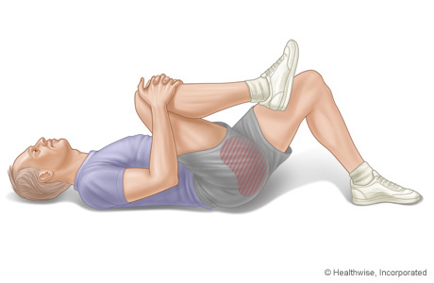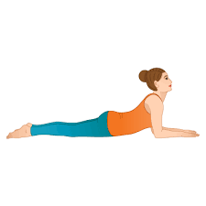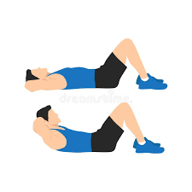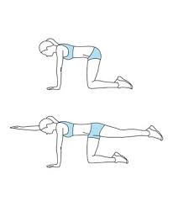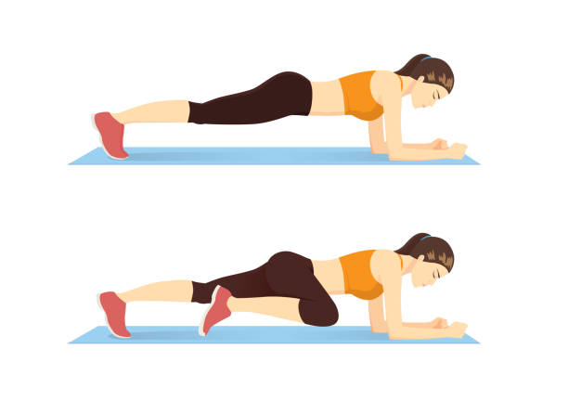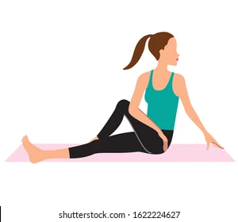

Bird Dog

1. Begin the exercise on the hands and knees with the shoulders directly over the hands and the hips directly over the knees.
2. Tense the abdominal muscles and stretch the right arm straight out in front of the body.
3. Hold the position while staying balanced.
4. Slowly lift the left leg and extend it straight out behind the body.
5. Hold the position for 15 seconds.
6. Slowly return to the starting position and repeat on the opposite side.

Knee to Chest steps:

1. Lie on your back with both knees bent and your feet flat on the floor.
2. Draw your one knee into your chest
3. Avoid lifting your hips or lower back.
4. Breathe deeply, releasing any tension.
5. Hold this pose for 30 seconds to 1 minute.
6. Repeat with the other leg.

Seated Spinal twist

1. Sit on the floor
2. Bend one of your knees and place your foot outside of your other thigh.
3. Place your right arm on the outside of your left thigh.
4. Place your left hand behind you for support.
5. Starting at the base of your spine, twist.
6. Hold this pose for up to 1 minute.
7. Repeat on the other side.

Abdominal Crunches

1. Lie with the back flat against the floor, the knees bent, and the feet flat and hip-width apart.
2. Cross the hands over the chest or reach along the sides of the body toward the feet.
3. Tighten the abdominal muscles and lift the head and shoulder blades off the floor while exhaling.
4. Lower to the starting position.
5. Repeat the above exercise 10–15 times.

Plank:

1. Lie on the stomach with the forearms against the floor and the elbows directly in line with the shoulders.
2. Tighten the abdominal and gluteal muscles.
3. Lift the hips and both knees off the floor
4. Hold the position for 10–30 seconds without allowing the pelvis to sag toward the floor.

Sphinx

1. Lie on your stomach with your elbows underneath your shoulders
2. Gently engage your lower back, buttocks, and thighs as you lift your head and chest.
3. Press your pelvis into the floor.
4. Breathing deeply and Hold this pose for 30 seconds to 1 minute.