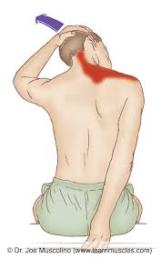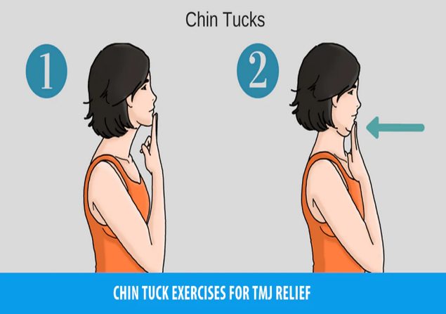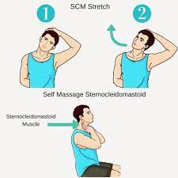

Upper Trap Stretch

1. While standing straight or sitting in a chair, take your right hand and place it on the back of your head. Take your left hand and tuck it behind your back.
2. Using your right hand, gently pull your head toward your right shoulder.
3. Hold this for 10–15 seconds.
4. Repeat on the other side.

Chin Tucks

1. Sit upright and look straight ahead with the ears directly over the shoulders.
2. Place a finger on the chin.
3. Without moving the finger, pull the chin and head straight back until a good stretch is felt at the base of the head and top of the neck.
4. Hold for 5 seconds if possible.
5. Bring the chin forward again to the finger.
6. Repeat for a total of 10 times, or as tolerated.

SCM Stretch

1. Sitting up straight and tall, take your right hand over the top of your head and reach down and across to the left side of your face with your fingertips.
2. Gently tilt your head towards the right shoulder as you push on it slightly with your right hand. You should feel a nice stretch in the muscles along the left side of your neck.
3. Hold for around 15-30 seconds before releasing slowly back to the center.
4. Repeat a few times on each side, focusing on taking slow deep breaths that allow you to sink further into the stretch with each repetition.