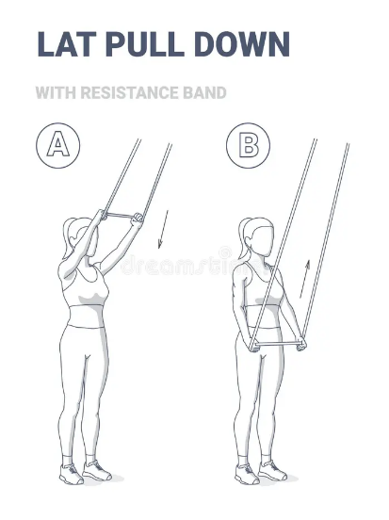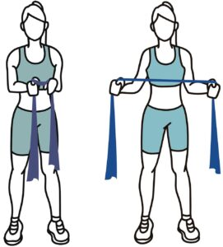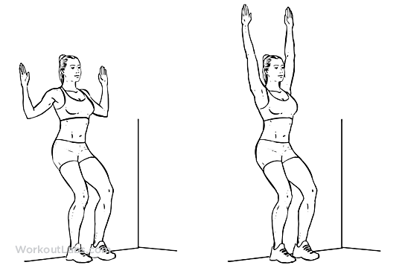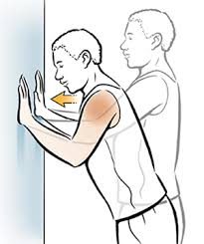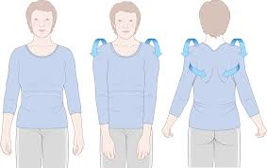

Lat Pull Downs

1. Sit or stand underneath a resistance band attached to a stable surface overhead.
2. Pull down on the band until your upper arms parallel the floor.
3. Pause at the bottom, squeezing your lats, then return to the starting position.
4. Complete 3 sets of 8–12 reps.

Resisted shoulder blade squeeze

1. for this exercise, you will need elastic exercise material, such as surgical tubing or Thera-Band
2. Sit or stand, holding the band in both hands in front of you. Keep your elbows close to your sides, bent at a 90-degree angle. Your palms should face up.
3. Squeeze your shoulder blades together, and move your arms to the outside, stretching the band. Be sure to keep your elbows at your sides while you do this.
4. Relax.
5. Repeat 8 to 12 times.

Wall Angel

1. Stand with your back flat against a wall. You may need to step your feet out slightly to allow your back to soften against the wall.
2. Extend your arms to create a “T” shape against the wall, then bend your elbows to create 90-degree angles.
3. Slowly move your arms up and down in a “snow angel” motion, ensuring they stay flat against the wall the whole time.
4. When your fingers touch above your head, return to the starting position.
5. Complete 3 sets of 10 reps.

Wall push ups

1. Stand against a wall with your feet about 30 to 60 centimeters back from the wall. If you feel any pain when you do this exercise, stand closer to the wall.
2. Place your hands on the wall slightly wider apart than your shoulders, and lean forward.
3. Gently lean your body toward the wall. Then push back to your starting position. Keep the motion smooth and controlled.
4. Repeat 8 to 12 times.

Shoulder Rolls

1. Stand or sit up straight, with your chin slightly tucked.
2. Keep your arms relaxed. All motion will be in your shoulders.
3. Roll your shoulders up, then back, then down, and then forward in a smooth, circular motion. Repeat at least 2 to 4 times.
4. Then go the other direction. Press your shoulders down, then back, then up, and then forward in a smooth, circular motion. Repeat at least 2 to 4 times.